QS5: STAR LAWS (Shedding Light on Astronomy) EPISODE V: How Does GPS Work?
Name: _____________________________________
- Why is every printed or online map of the world distorted? ______________________________________
____________________________________________________________________________________________________________________________________________________________________________
- Map projection is the process by which the co-ordinates on a _________-dimensional ______________ surface (like the surface of the Earth) are converted into co-ordinates that can be represented on a ___________-dimensional __________ surface (like a piece of paper or a screen). Projection always introduces some ___________________.
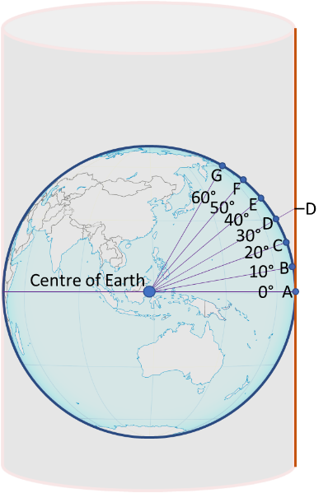
- Points A – G are points on the Earth that are spaced evenly at 10° latitude intervals. The vertical line represents a section of a flat grey paper onto which a map will be projected. By extending the lines that are coming from the centre of the Earth, mark on the vertical line where each point would appear on the flat map.
Point D has been done for you.
- In real life, Points A and B are the same distance apart as Points G and F. How will the map show these points?
________________________________________________________________
________________________________________________________________
________________________________________________________________
________________________________________________________________
________________________________________________________________
(Note: the process in real life is done mathematically.)

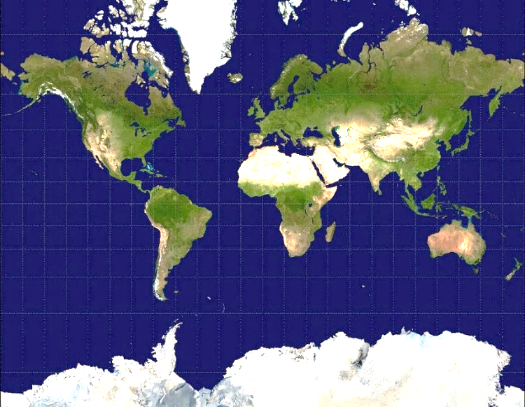
- The Mercator Projection, shown on the right, has been the most widely used map for navigation purposes. What are two of its advantages and what is its most obvious weakness?
Advantage 1: ____________________________
_______________________________________
_______________________________________
Advantage 2: ____________________________
_______________________________________
_______________________________________
Weakness: ______________________________
_______________________________________
______________________________________________________________________________________
(Please Note: It’s not really a weakness because it was produced for navigation purposes.)
- GPS navigation is made possible by a fleet of about ______ satellites that orbit the Earth at a height of about _________________________ kilometres.
- The signals sent by satellites (which are forms of electromagnetic waves) travel at a speed of ______________________ kilometres/second. (This speed is also the speed of visible light.)
- Write the equations that link time, distance, and speed.

speed = $\frac{------- ------}{------------------}$ time = $\frac{------- ------}{------------------}$
distance = _______________× _______________
- A signal is sent by a GPS satellite at exactly 10 am. A GPS-enabled phone receives the signal exactly 0.08 seconds later. How far was the phone from the satellite when the signal was sent?
distance = __________________ km
TRILATERATION EXERCISE
- The map of Victoria below shows the position of three GPS satellites. The satellites are about 20,000 km above the surface of the Earth, but for the purposes of this exercise, we’re going to flatten everything into 2D. The three satellites send a signal which are picked up by a phone.
(a) The phone determines that it is 4.5 cm from Satellite 1. Using a compass, draw a circle of radius 4.5 cm around the point that represents Satellite 1. What marked towns might you be in? ___________________________________________________________________________________
(b) The phone determines that it is 5 cm from Satellite 2. Draw a circle of radius 5 cm around the point that represents Satellite 2.
(c) The phone determines that it is 4 cm from Satellite 3. Draw a circle of radius 4 cm around the point that represents Satellite 3.
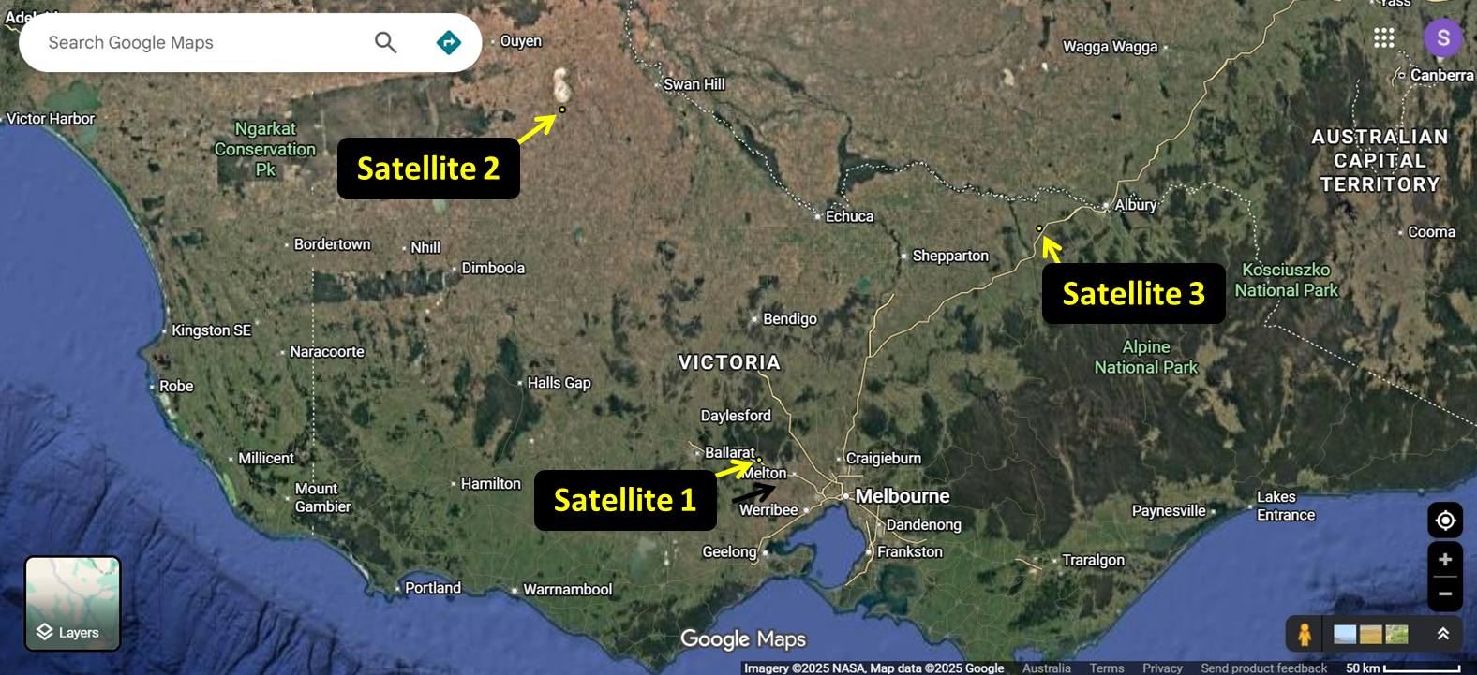
(d) Where is the phone? _________________________________________

